**Procedural Method for Selection for Ivy Miller-Gladys Dillon Carman-Ainsworth High School National Honor Society Chapter**

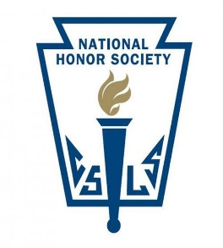

**Disclaimer: Students with a 3.2 do not have the right, nor are automatically accepted into the NHS.**

1. **Discipline and academic records are generated and printed:**
   1. During late fall of the start of the school year (after end of 1st semester), students who are at, or above **3.2 GPA** are sought out for selection
   2. Advisors look for any discipline issues for students who are at/or above 3.2.
   3. Once a student has been deemed eligible, they are notified by the Advisors and Advisory Council for acceptance, depending on approval of the vetting process
2. **Vetting Process:**
   1. Once a student has been selected, they are provided with vetting document asking for completion of the following:
      1. Three (3) teacher signatures who work in the building
      2. Two (2) word essay documents (350 word count for each essay); One essay is about Character and the second is about service.
      3. Essays must demonstrate, to a large degree the ability to tell how they are a good fit for the NHS. Writing skills and the ability to connect meaning and thought are highly considered
      4. Students, then, submits application packet to the advisor(s) by the required due date. Note: Although there may be unforeseen circumstances, and students do not meet deadline, the application packet may be denied.
      5. Applications are divided and provided to the NHS Advisory Council for review and given a score based on the requirement in the packet.
      6. If the student is denied, the student has no right to claim that they should be or have been accepted into the NHS.
3. **Acceptance** 
   1. Once Advisory Council has deemed that the student is official, and has met the standards of candidacy, the Advisory Council provides Advisors with list of names for promotion to an NHS candidate.
   2. Candidate is now notified by written and hand delivered document requesting their acceptance into the **Ivy Miller-Gladys Dillon Carman-Ainsworth High School National Honor Society Chapter.**
   3. Document requests the signature of parent(s) and candidate and request for attendance at a formal induction ceremony in the fall at the start of the school year, 1st semester. Note: Although there may be unforeseen circumstances, and students are not able to attend induction ceremony, Advisory council may deny or approve acceptance into NHS. All candidates are highly encourages to attend inductions

Sincerely,

**Kathleen Waters**

Ms. Kathleen Waters,

Advisor

**Boris D. Turner**

Boris D. Turner, Ph.D.,

Advisor